

**Proofreader application: Test copy**

If you would like to be considered to join our team as a proofreader, please complete this test piece of proofreading.

In the document that follows, please proofread everything and tidy up the formatting as needed, including addressing the points in comments. Please turn on tracking, add any comments as you see fit and use the ‘styles’ function where appropriate.

Save the completed test with your name in the filename and upload it where indicated on the application form (links to the application form are at <https://sortedcomms.co.uk/careers/>)

For your reference, if this was a real piece of work for a client, I would expect it to take about half an hour.

|  |
| --- |
| For office use |
| Score: |
| Comments: |

Understanding population health

Population heath analysis is an essential tool for anyone working in an ICS, planning new interventions or new care models, or looking for the best ways to close the gap on health inequalities.

It delivers a real understanding of a population’s health and can be to facilitate decision-making, and to help ensure that funding is targeted towards those areas where there is the biggest opportunity to make the maximum impact in health and wellbeing.

Our comprehensive population health analyses gives a detailed picture of the health of communities, the challenges or risks faced by different groups, the ways in which they engage with health and other public services, and the ways in which services can be changed to benefit their wellbeing.

# What we offer

Our population health analyses don’t only look at the wellbeing of a population, they also look in detail at how the implementation of a proposed new initiative is likely to play out within the targeted sections of that population. We start with risk stratification and segmentation, and then build on the analysis with a number of ground-breaking ‘extras’:

* **Risk segmentation:** Giving a detailed picture of the communities health and wellbeing and the challenges or risks faced by different groups within the population.
* **Gap and opportunity analysis** Identifying and focusing on patient care that may have missing elements or ‘gaps in delivery, and identifying potential areas for improvement.
* **Impactibility assessments:** Identifying which patients are most likely to be amenable to a new intervention and which interventions would be most effective.

Our initial assessments first of how the implementation of a new innovation may benefit the target group or population segment, and we can then offer additional support through providing a health equality impact assessment, running a series of evaluations to check whether the change being made was making a difference, creating a learning health system or a PDSE cycle (plan, do, study, act) and continually iterating an intervention to ensure it’s going the right direction to achieve the desired.

**Why choose ICHP?**

Our business intelligence team is leading the way in population health analysis, providing guidance on the metrics used in the national population health analytics dashboard commissioned by NHS England. Furthermore other significant projects including providing national dashboards for population health management for atrial fibrillation for NHS RightCare, and for sepsis for the Patient Safety Collaborative.

We have a strong and growing analytics team with access to, and knowledge of, local and national datasets, providing our health economists with the real-world data they need to produce impactful and insightful analyses.

Access to data

ICHP’s access to data is second to none – a crucial advantage in a realm where the best possible data is essential for the best decision-making. In addition to publically available datasets from NHS digital, Public Health England and the Office of National Statistics, ICHP have access to a number of specialist information assets.

## Record level hospital activity data (HES)**[1]**

A 10-year dataset linked at depersonalised patient record level by a unique HES ID number, enabling longitudinal analysis. This dataset is available for all NHS organisations nationally and incorporates inpatient, outpatient, A&E, critical care and mental health data. Civil registry mortality data is now also included in this dataset, enabling enhanced analysis related to health and mortality.

**2 The North West London Whole Systems Integrated Care (WSIC) database**

A unique dataset, created for the purpose of direct care which links primary, secondary, mental health, community and adult social care data for over two million people and 370 GP practices in NWL

1. **3. Clinical Practice Research Datalink (CPRD)**

Anonymised primary care records for public health research. A governmental, not-for-profit research service, CPRD, is jointly funded by the NHS National Institute for Health Research (NIHR) and the Medicines and Healthcare products Regulatory Agency (MHRA) - a part of the Department of Health and Social Care. ICHP has access to reports from a CPRD-HES linked database to undertake research via our data partners Harvey Walsh.

**4. Discover**

An essential tool for finding patients and healthy members of the North West London population who meet the clinical requirements for research trials, whilst also providing access (via WSIC) to a level of real world, de-identified health and social care data that is unrivalled in the UK.

**Where we work**

ICHP operates across NorthWest LondonThe graph below shows the average population of London

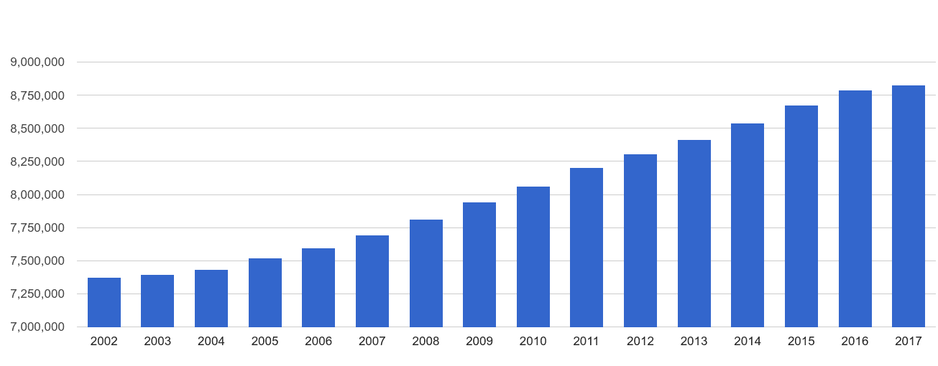**About us**

The IHCP Business intelligence team provides statistical, economic and scenario modelling to organisations across the country which require rigorous and robust analysis with expert insight. We offer first-rate analytics delivered by people who understand the complexity of the NHS. With access to, and demonstrable experience in working with, complex, integrated and linked datasets we can provide the most informed models to support decision-making.

ICHP is a not-for-profit partnership organisation bringing together NHS providers of healthcare services, clinical commissioning groups and leading Universities across North West London. We are also the designated Academic Health Science Network (AHSN) for North West London and members of the national AHSN Network.

ICHP innovates and collaborates for a healthier population. We turn the potential of innovation into reality to help solve pressing challenges by collaborating across the health sector. By connecting a unique network of health experts, we can accelerate the adaption and spread of innovation amongst our member organisations.

Find out more about our population heath services: <client to insert contact details>

1. Derived data HES outputs are created in partnership with Harvey Walsh Ltd, who work collaboratively with ICHP in the provision of data insights from their proprietary database AXON 360 (Harvey Walsh NHS Digital DSA: DARS-NIC-05934-M7V9K).